|  |
| --- |
|  |
| MOTORIDE |
| Project Documentation of DISM (Semester II) |

**our team members**

* MARIAM ABDUL WAHID Student1059491
* SHAIKH TAHA ALEEM Student1074265

**Faculty** = Miss Aatika Liaquat

**Batch Code** = 1803B2

**Curriculum**= 6673

**Semester**= HDSE-2

**Table of Contents: -**

1. Acknowledgment....................................................................................................... 4
2. Abstract………………………………………………………………………………………………………………… 4
3. Declaration…………………………………………………………………………………………………………… 5
4. Certificate…………………………………………………………………………………………………………….. 6
5. **CHAPTER I :** INTRODUCTION…………………………………………………………………………………. 8
6. Problem Statement………………………………………………………………………………… 8

* Objectives…………………………………………………………………………………… 8
* Functional Requirements……………………………………………………………. 9
* System Administrator…………………………………………………………………. 9
* System User………………………………………………………………………………… 9

1. Need of Project……………………………………………………………………………………… 10
2. **CHAPTER II** : PROJECT MAKING & BACKGROUNDS………………………………………………. 11
3. Project Duration………………………………………………………………………………………. 12
4. Task Sheet……………………………………………………………………………………………….. 13
5. **CHAPTER III** : SOFTWARE & HARDWARE REQUIREMENTS…………………………………… 14
6. Hardware Requirements……………………………………………………………………………. 15
7. Software Requirements……………………………………………………………………………… 15
8. **CHAPTER IV** : WORKFLOW SUBMISSION CHECKLIST…………………………………………… 16
9. Workflow Submission Checklist…………………………………………………………………….. 17
10. Screenshots…………………………………………………………………………………………………… 18
11. Application Map…………………………………………………………………………………………….20
12. **CHAPTER V**: CONCLUSION………………………………………………………………………………….. 20
13. Remarks………………………………………………………………………………………………………… 22
14. Application……………………………………………………………………………………………………. 22
15. Problem Faced……………………………………………………………………………………………… 22
16. Future Enhancement……………………………………………………………………………………… 22

1- Acknowledgement:

We would want to appreciate and thank all of those people who helped us during this journey of completing our project. Without everyone’s support, we could not have accomplished our work.

We express our sincere gratitude to our faculty “--Miss Aatika Liaquat--" and our coordinator for their amazing support and guidance, continuous encouragement and supervision throughout the course of the present work. It’s of no doubt that we have been very fortunate to work under such a supportive and cooperative teacher/coordinator

And last but not the least we are extremely grateful to the whole faculty and administration of Aptech, for providing us all the facilities that were mandatory, without which this project could not be a success.

2- Abstract:

The capstone project **“MOTORIDE”,** I have been working on is about the development of a desktop application for a Moto Shop. It’s made using PHP and MySQL Database Mainly. This application has as purpose to help my client in managing his work; as for any Owners well as their employees.

The Motoride application will offer several features such as in this the user can rent a car by choosing the type of the car as well as the company of the car. This user can choose the time period for which they want to book the car for. In this the user can register the details of the car (including the company name of the car). The timing in which they can place the car for rent. The user can also register their car for selling purpose making the client work easy and efficient. The report reflects the work done and its progress and describes in more details of this project’s stages.   
  
The project’s first stage is the requirements and specification stage. During this stage, the client’s needs are gathered and proceeded; for MOTORIDE application, the requirements were

expressed explicitly.

Once this phase done, comes up the feasibility study where the technical aspect is

tackled. This stage is partially driven by the application’s type to be developed, technology

enablers such as programming language, and database.

After the feasibility study done comes the design and analysis phase with the design of

database entities.

Finally comes the implementation phase with a description of all the necessary tools

used to develop the application.

3- Declaration

We are writing this to declare that all the work which is being written bellow in this Project Report entitled “—**MOTORIDE**--” is a veritable record of our own work submitted to the Aptech NN, Karachi, Pakistan during the year 2020 in the partial fulfillment of semester IV (HDSE-II) project We also declare that we have not submitted the material being presented in this Project Report for the award of any other degree elsewhere.

Signatures:

MARIAM ABDUL WAHID Student1059491

SHAIKH TAHA ALEEM Student1074265

=

Certificate: -

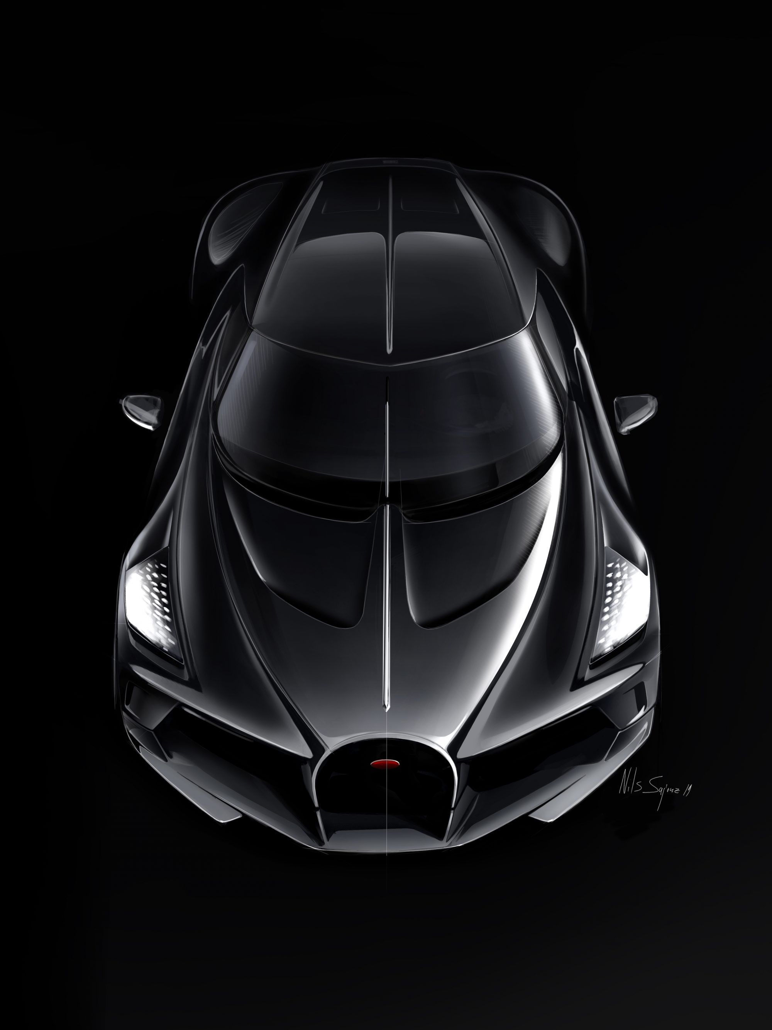

This is to certify that,

Mr. / Ms.

**MARIAM ABDUL WAHID**

**SHAIKH TAHA ALEEM**

Has successfully Designed & Developed

**MOTORIDE**

Authorized Signature: **Miss Aatika Liaquat**

INTRODUCTION

Problem Statement: -

#### **MOTORIDE: -**

Almost every activity in the world today is controlled by computer driven software programs. His trend was first accommodated by engineering applications in the past. However, as the lifestyle became more and more complex, every area of human interactions was invaded by various software systems, such as real time, business, simulation, embedded, web based, personal and more recently, artificial intelligence software etc. According to the above facts, managing and maintaining a moto shop could also be controlled by efficient software.

In real world, it tends to associate with automated systems as they provide many benefits than doing the same thing in manually. As above mentioned, here we have introduced a system which can be used to maintain a MOTORIDE. When we are concerning the manual process of a MOTORIDE, the major problem is the waste of time. A customer has to waste his/her valuable time when he needs to rent a ride as all the events such as searching, purchasing are done by members of the staff. In briefly, the manual process is very slow. But automation will reduce the time taken in the whole process.

**OBJECTIVES:**

This MOTORIDE is used to overcome the entire problem which they are facing currently, and making manual system to computerized system Purposed MOTORIDE management system should help the user to rent a car by choosing the type of the car as well as the company of the car. In This user can choose the time period for which they want to book the car for. In this the user can register the details of the car (including the company name of the car). The timing in which they can place the car for rent. The user can also register their car for selling purpose making the client work easy and efficient. The objective and scope of my Project MOTORIDE System is to record the details various activities of user.

**FUNCTIONAL REQUIREMENTS:**

**User Interface: -**

The system users are:

* The MOTORIDE as the system administrators.
* MOTORIDE employees as the normal users.

**SYSTEM ADMINISTRATOR: -**

• The administrator logs on to the system by inserting administrator username and password.

• Administrator can do any transaction as well as editing all details inside the database such as adding, editing and deleting a new user or adding, editing and deleting items.

**SYSTEM USER: -**

This project consists of two users and one admin.

**User (Rentee):**

* In this the user can rent a car by choosing the type of the car as well as the company of the car.
* This user can choose the time period for which they want to book the car for.

**User (Owner):**

* In this the user can register the details of the car (including the company name of the car)
* The timing in which they can place the car for rent.
* The user can also register their car for selling purpose.

**Admin:**

**Add, Delete Cars:** The admin has the option to place the car on rent according to the details given on the car.

**Website Data:** He has the option to delete, add and maintain the website.

**Contact Us Page:** Admin Can Update Delete & Change the Contact details.

**About Us:** Admin Can Update & Delete the Information about the Website.

**Registered Users:** Admin Can View All Registered Users on Website

Need of Project: -

Some of the benefits of Project are as under: -

* Re-enforcement of Skills happens in the experiential learning process.
* A mentor, ensuring that you do not get drifted, constantly guides you.
* It gives you a lot of confidence to face an interview as you have worked on a project. You can explain virtually everything on the subject you have learnt.
* A nice, final, black, hardbound report adds to you credentials and enhances your job prospects.
* Projects is compulsory (Sem-End Project) and is supposed to be done over and above the assignments given in your course books.
* It is advised that if a student follows the projects and submits Assignments, he would definitely have an edge over other students.
* Students need to submit their project report along with working application and source code in the stipulated time.



PROJECT MAKING & BACKGROUND

PROJECT DURATION: -

* Analysis- 3 days
* Design – 17 days
* Development –5 days
* Testing – 3 days
* Documentation -2 days

|  |  |  |  |  |
| --- | --- | --- | --- | --- |
| Analysis | Design | Database | Testing | Documentation |

|  |  |  |  |  |  |  |  |  |  |  |  |  |  |  |  |  |  |  |  |  |  |  |  |  |  |  |  |  |  |
| --- | --- | --- | --- | --- | --- | --- | --- | --- | --- | --- | --- | --- | --- | --- | --- | --- | --- | --- | --- | --- | --- | --- | --- | --- | --- | --- | --- | --- | --- |
| 1 | 2 | 3 | 4 | 5 | 6 | 7 | 8 | 9 | 10 | 11 | 12 | 13 | 14 | 15 | 16 | 17 | 18 | 19 | 20 | 21 | 22 | 23 | 24 | 25 | 26 | 27 | 28 | 29 | 30 |

TASK SHEET

|  |  |  |  |  |  |
| --- | --- | --- | --- | --- | --- |
| **No.** | **Task** | **Actual Start Date** | **Actual Days** | **Team Mate Name** | **Status** |
| 1. | Case Study | 31st Jan 2020 | 2 | MARIAM ABDUL WAHID | Completed |
| 2. | UI Designing | 3rd Feb 2020 | 9 | MARIAM ABDUL WAHID | Completed |
| 3. | SCENARIO Making | 12th Feb 2020 | 8 | MARIAM ABDUL WAHID | Completed |
| 4. | Material Searching | 16th Feb 2020 | 3 | MARIAM ABDUL WAHID | Completed |
| 5. | Database Connectivity | 20th Feb 2020 | 6 | MARIAM ABDUL WAHID | Completed |
| 6. | Documentation | 27th Feb 2020 | 2 | SHAIKH TAHA ALEEM | Completed |



SOFTWARE & HARDWARE REQUIREMENTS

HARDWARE REQUIREMENTS: -

* A minimum computer system that will help you access all the tools in the courses is a Pentium 166 or better.
* 64 Megabytes of RAM or better.

SOFTWARE REQUIREMENTS: -

* NotePad
* Browser Google



WORKFLOW SUBMISSION CHECKLIST

## 

WORKFLOW SUBMISSION CHECKLIST:-

|  |  |  |  |
| --- | --- | --- | --- |
| **S.NO** | **LIST OF ITEMS** | **Remarks** | **COMMENTS** |
| 1. | Do All Forms Linked together | **Yes** | By making their objects. |
| 2. | Database Connected | **Yes** | Using  MDF FILE |
| 3. | Page Colors As Per Common Guidelines | **Yes** | Professional Color Combination |
| 4. | All SQL Queries Working | **Yes** | Linked through a single Connection Class |
| 5. | DOCUMENTATION Included | **Yes** | All 3 word documents. |
| 6. | Project Zip File | **Yes** | Created using WinRAR |

SCREENSHOTS: -

# Login Page

# 

# DashBoard

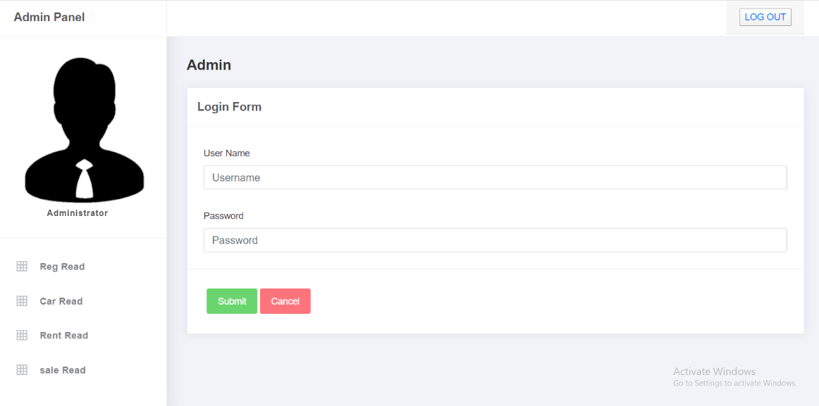

# 

# 

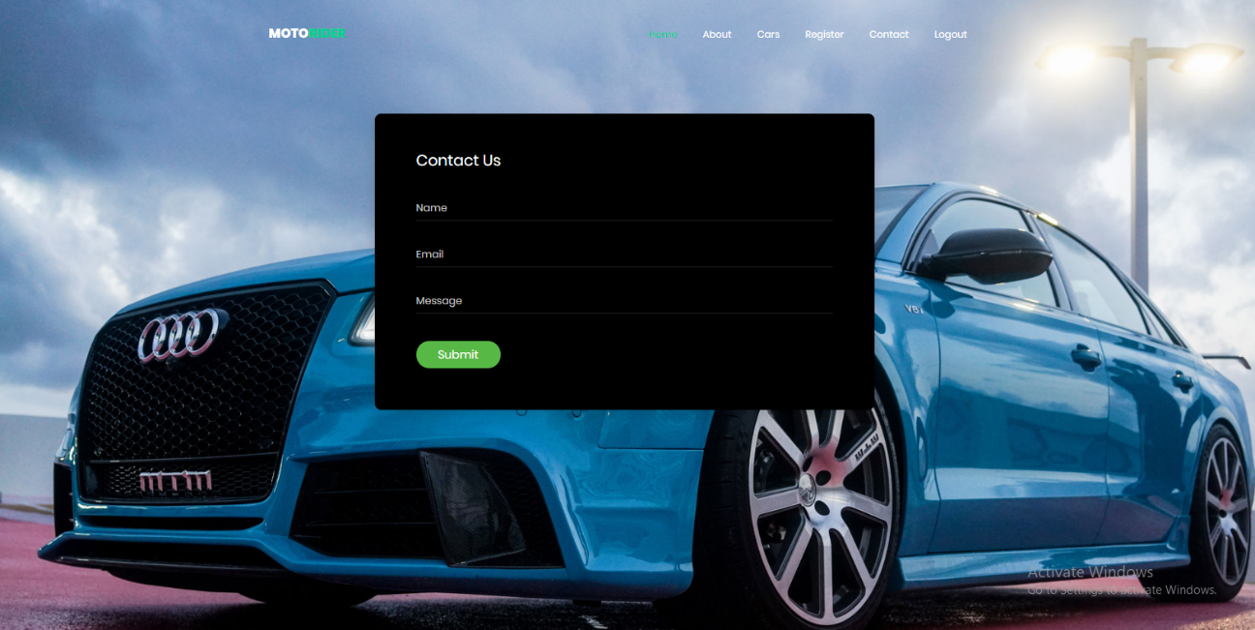

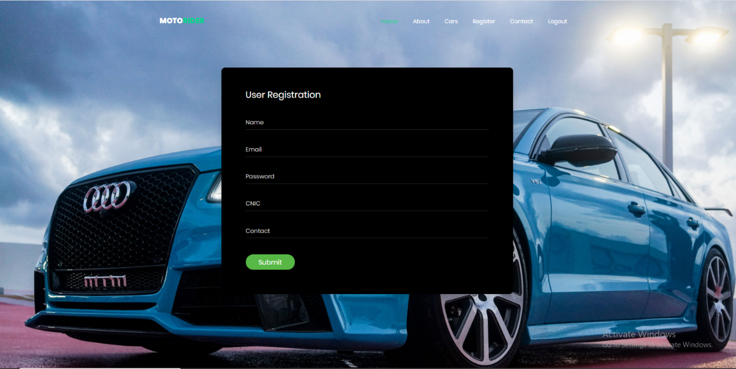

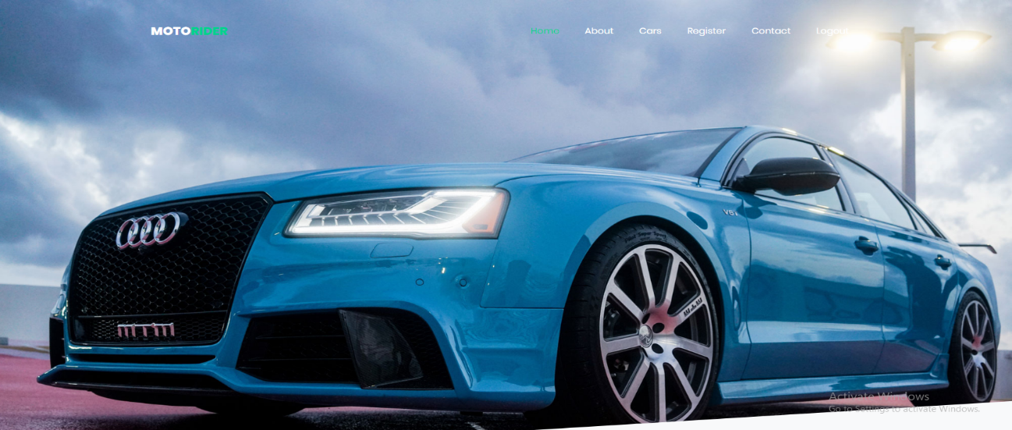

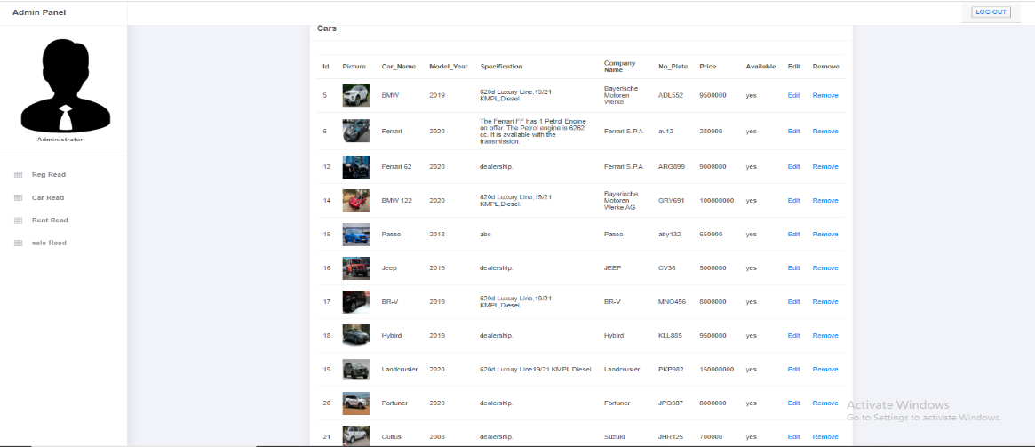

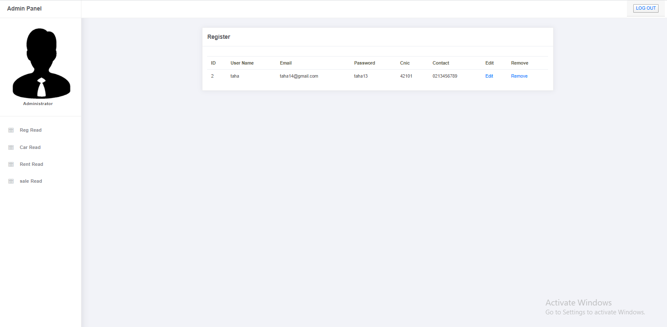

APPLICATION MAP: -

**MOTORIDERS**

**LOGIN**

**ADMIN**

**USER**



CONTACT US

HOME

ABOUT

CARS



CONTACT US

REGISTER

CARS

ABOUT

HOME

CONCLUSION

Remarks: -

It is very nice initiative that has made us work harder on our project and it has polished our skills now we are capable of making a php website all by our own self. We are very thankful to you.

Application: -

It’s MOTORIDE system. It can be a online platform for customers for a place of cars and with further enhancements. It is also very useful for the customer that face a lot of problems in their MOTORIDE.

Problem Faced: -

The main problem we faced in the duration of project is the load shedding problem. We work on project then suddenly computer was off.

Future Enhancement: -

It is almost a perfect prototype of this php website can be deployed and used in real world! But there is always a place for betterment so ere are our few suggestions, categories can be added in cars so that searching becomes easier. Also, interaction with our regular customers can be maintained using mail, message etc.